### [**Dump Truck Paper Model**](https://papercraftetc.blogspot.com/2018/12/dump-truck-paper-model.html)

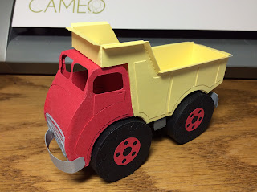

I made this model for Juanita who said she couldn't find a nice model of a dump truck. This truck takes about three hours to construct. Cut out all of the pieces and plan how you are going to construct the dump truck by looking at the photos. I recommend gluing on all of the veneer pieces before constructing the truck. Also bend all of the tabs before trying to glue any of the pieces together. The yellow truck bed should be glued from the top edge first, a few tabs at a time until you get to the bottom of the first corner. Align the rest of the tabs and corners. After all of the corners and edges are aligned, then glue the tabs down. For the cab of the truck, start gluing from the windshield and go downwards. Glue one or two tabs at a time and let them dry completely before continuing. There are two tabs that meet at the bottom edge of the cab. The tabs lay on top of one another. I placed the back piece tab on top of the front piece tab. The cab is glued to the yellow truck bed on the back of the cab piece. The tires are constructed by gluing the front of the tire to the treads first. Do not glue the back of the tire. Construct the undercarriage and then attach the back tire tab to the undercarriage. Wait for the glue to dry on the back tire tab. Attach the undercarriage to the body of the truck with glue. Once the undercarriage is attached, glue the front of the tire to the back to complete the construction of the tire. I added a box structure between the front and back tires, instead of an axle, to make the tires secure so they will not wobble.  
  
I used colored card stock and metallic card stock to construct this model.

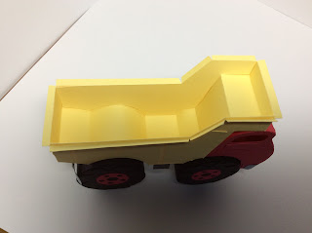

Inside of the truck bed has a lining to hide the tabs on both sides.

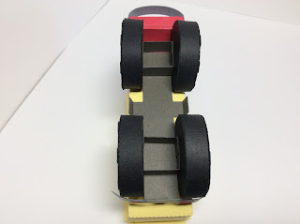

Notice the box structure between the tires. This was done to secure the tires so that they do not wobble because there is no axle.

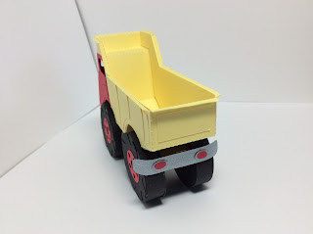

The back undercarriage tab is used to glue on the back fender. I glued two undercarriage pieces together to make the undercarriage more secure.

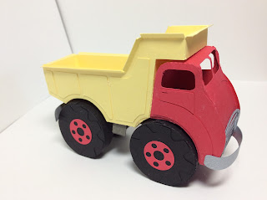

The front fender is glued on in just two places on the sides of the truck.

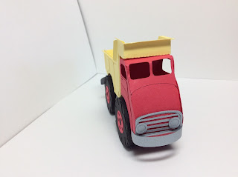

Notice the placement of the grill and headlights.

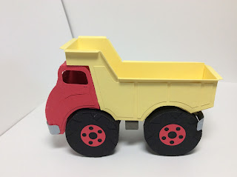

The top edge of the entire truck bed has a bent edge.which is folded downward.